DLLS IN WINDOWS 🧩
1. What a DLL Really Is
A Dynamic-Link Library (DLL) is a file that contains functions and resources that are used by other programs.
It is not a standalone program and cannot run by itself.
DLLs exist to share code and data between multiple executables.
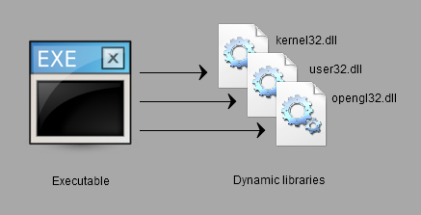
2. How DLLs Differ from Executables
- EXE → starts execution, owns the process.
- DLL → loaded into an existing process and provides services.
A DLL has:
- No WinMain
- No message loop
- No independent lifetime
It lives only as long as the program using it.

3. Dynamic Linking (What “Dynamic” Actually Means)
Dynamic linking happens at runtime, not at compile time.
Flow:
- Program starts.
- Windows loads required DLLs.
- Function calls inside the program are resolved to DLL code.
- Execution continues as if the code were local.
Result:
- One copy of code
- Used by many processes
- Loaded only when needed

4. DLLs Are the Fabric of Windows 🧠
Windows itself is built from DLLs.
Examples:
- KERNEL32.DLL → processes, memory, files
- USER32.DLL → windows, messages, input
- GDI32.DLL → graphics and drawing
- Device drivers
- Font engines
Writing a DLL is effectively extending Windows, not just writing helper code.

5. DLL File Extensions
- .DLL → standard and auto-loaded
- Other extensions → allowed, but must be loaded manually
Manual loading uses:
- LoadLibrary
- LoadLibraryEx
Rule: If Windows doesn’t recognize the extension, you must load it yourself.

6. Why DLLs Exist (Real Advantages)
Code Reuse
- One implementation
- Many programs
- Less disk usage
- Less memory usage
Independent Updates
- Fix the DLL
- No need to recompile dependent programs
- As long as the interface stays stable
Shared Resources
- Fonts
- Icons
- Images
- Tables
- Data blobs

7. DLLs in Large Applications
DLLs shine when applications are split into many programs.
Example:
- Accounting software
- Multiple tools
- Shared calculations
- Shared data logic
Instead of duplicating code:
- Put common logic in ACCOUNT.DLL
- All tools use the same implementation

8. DLLs as Products
DLLs can be commercial products.
Example:
- GDI3.DLL with 3D drawing routines
- Licensed to many graphics applications
- Users install one copy
- All programs benefit
This is how real software ecosystems are built.

TYPES OF “LIBRARIES” IN WINDOWS ⚙️
The word library is overloaded. These are not the same thing.

9. Dynamic-Link Libraries (DLLs)
- Loaded at runtime
- Shared between processes
- Provide executable code and resources
- Central to Windows design

10. Object Libraries (.LIB)
- Statically linked
- Code becomes part of the EXE
- No runtime sharing
- Cannot be updated independently
Example:
- C runtime static libraries
Once linked, they are part of the executable forever.

11. Import Libraries (.LIB)
Import libraries are not code containers.
They are:
- Linker instructions
- Address maps
- Function name translators
Purpose:
- Tell the linker how to call into a DLL
- Enable clean dynamic linking at build time
They exist only to bridge EXE ↔ DLL.

12. When Each Is Used
- DLL → runtime execution
- Object library → compile-time inclusion
- Import library → compile-time setup for runtime DLL usage
This separation is intentional and powerful.

DLL LOADING MECHANISM 🔍
13. How Windows Finds a DLL
Windows searches in this order:
- Program directory
- Current working directory
- System directory
- Windows directory
- Directories in PATH
Understanding this order is critical for debugging DLL issues.

PROJECT AND WORKSPACE STRUCTURE 🧱
14. Workspace vs Project
- Workspace → container for related projects
- Project → builds one thing (DLL or EXE)
Large systems always use multiple projects.

15. DLL Project Components
Header Files
- Define exported functions
- Define shared structures
- Act as the DLL’s public contract
Source Files
- Actual implementation
- Internal logic
- Hidden details
Rule:
Headers describe what the DLL offers,
source files implement how it works.

MENTAL MODELS THAT MATTER 🧠
- DLL = shared toolbox
- EXE = worker using tools
- Import library = instruction manual
- Runtime linking = flexible and efficient
- Static linking = fixed and heavy

WHAT’S COMING NEXT 🚀
- Reading real DLL headers
- Understanding exported functions
- Seeing EXE ↔ DLL interaction
- Breaking and fixing linkage mistakes
This is real Windows architecture, not theory.

EDRLIB.H and EDRLIB.C
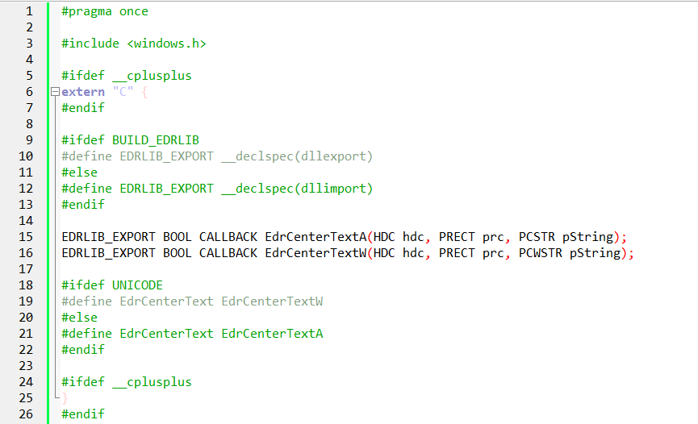

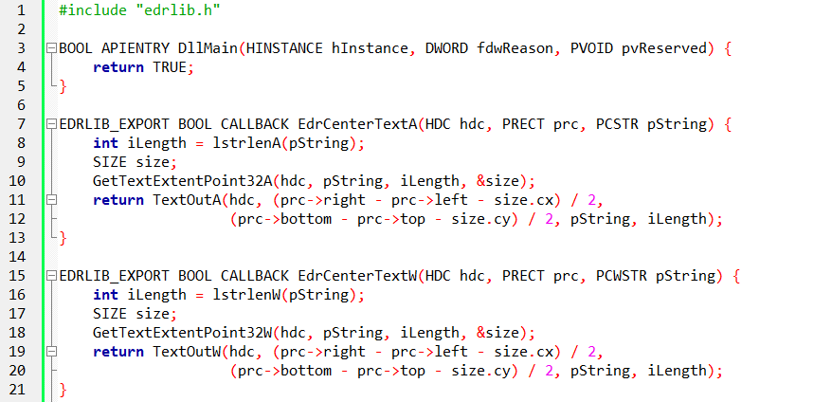
EXPORTING FUNCTIONS FROM A DLL 🧩
1. #pragma once
#pragma once ensures a header file is included only once during compilation.
Why it exists:
- Prevents duplicate definitions
- Replaces classic #ifndef / #define include guards
- Simpler and less error-prone
Important:
- Not part of the C standard
- Fully supported by MSVC and most modern compilers
- Safe to use in Windows projects
Mental model:
One header, one inclusion — no accidents.

EXPORTING AND IMPORTING SYMBOLS 🔗
2. __declspec(dllexport) and __declspec(dllimport)
These are Microsoft-specific attributes that control symbol visibility across module boundaries.
- __declspec(dllexport)
  - Used when building the DLL
  - Marks functions or data as exported
  - Makes them visible to other modules
- __declspec(dllimport)
  - Used when using the DLL
  - Tells the compiler the symbol lives elsewhere
  - Enables efficient calling through the import table
Rule: Same header, two meanings — depends on who is compiling.

3. The EDRLIB_EXPORT Macro (Correct Pattern)
The macro switches behavior based on a build flag.
Logic:
- When building the DLL → export
- When consuming the DLL → import
This avoids:
- Duplicate headers
- Manual edits
- Mistakes across projects
Mental model:
One header rules both sides.

FUNCTION DECLARATIONS (ANSI vs UNICODE) 🧠
4. EdrCenterTextA and EdrCenterTextW
Windows uses a dual-function pattern:
- A → ANSI (8-bit)
- W → Wide / Unicode (UTF-16)
Why both exist:
- Backward compatibility
- Explicit encoding control
- Performance predictability
Each function:
- Receives a device context (HDC)
- Receives a rectangle (RECT)
- Receives a string
- Draws text centered in that rectangle

5. The EdrCenterText Macro
This macro selects the correct function automatically.
- UNICODE defined → EdrCenterTextW
- UNICODE not defined → EdrCenterTextA
Why this matters:
- Call sites stay clean
- Encoding choice becomes a build decision
- Same source works in both worlds
This is classic WinAPI design.

extern "C" — WHY IT MATTERS ⚠️
6. Preventing Name Mangling
When compiling with C++:
- Function names get mangled
- Symbol names change
- DLL exports break silently
extern "C":
- Forces C linkage
- Keeps symbol names predictable
- Allows C and C++ code to interoperate
Rule:
DLL boundaries hate name mangling.

DLL IMPLEMENTATION (EDRLIB.C) 🧱
7. DllMain — The Real Entry Point
DLLs don’t have WinMain.
They have:
This function is called by Windows when:
- DLL is loaded
- DLL is unloaded
- Threads are created
- Threads are destroyed
In this DLL:
- DllMain returns TRUE
- No initialization logic
- Safe and minimal
That’s intentional.

IMPLEMENTING THE EXPORTED FUNCTIONS 🧠
8. EdrCenterTextA
Steps:
- Compute string length (lstrlenA)
- Measure text size (GetTextExtentPoint32A)
- Compute centered position
- Draw text (TextOutA)
Key idea:
Measure first, draw later — never guess.

9. EdrCenterTextW
Same logic as the ANSI version, but:
- Uses wide strings
- Uses W versions of APIs
This guarantees:
- Correct Unicode handling
- No encoding bugs
- Predictable output

BUILD OUTPUTS 🏗️
10. What the Build Produces
- EDRLIB.DLL → the actual executable code
- EDRLIB.LIB → the import library
Important distinction:
- .DLL → loaded at runtime
- .LIB → used by the linker
Mental model:
LIB = instructions
DLL = execution

TEXT ENCODING STRATEGY 🧬
11. Why ANSI + Unicode Still Exists
Windows evolved, not rebooted.
DLL design must:
- Support legacy code
- Support modern Unicode
- Avoid forcing decisions on users
The macro-based switch:
- Centralizes encoding choice
- Keeps APIs clean
- Avoids duplicated call logic

DllMain — LIFE CYCLE EVENTS ⚙️
12. DLL_PROCESS_ATTACH
Triggered when:
- A process loads the DLL
Typical tasks:
- Initialize global data
- Allocate resources
- Prepare internal state
Rules:
- Keep it fast
- No heavy work
- No blocking calls

13. DLL_PROCESS_DETACH
Triggered when:
- Process unloads the DLL
Responsibilities:
- Free memory
- Close handles
- Release resources
Failure here causes:
- Memory leaks
- Handle leaks
- Silent system instability

14. Thread Notifications
- DLL_THREAD_ATTACH
- DLL_THREAD_DETACH
These fire for every thread in the process.
Important warning:
- Avoid complex logic
- Avoid messaging APIs
- Avoid synchronization traps
Many real bugs live here.

CRITICAL RULES FOR DllMain ⚠️
15. What NOT to Do
Never:
- Call LoadLibrary
- Call FreeLibrary
- Create threads
- Perform blocking I/O
- Use complex synchronization
Reason:
Loader lock.
Violating this leads to:
- Deadlocks
- Random crashes
- Impossible-to-debug failures

ADDITIONAL PRACTICAL NOTES 🧠
16. hInstance
- Identifies the DLL module
- Needed for resource loading
- Often stored globally

17. Multiple Processes
- Each process gets its own instance
- Global variables are per process
- DLL code is shared, data is not

18. Thread Safety Reality
- DllMain can be called concurrently
- Shared state must be protected
- Minimal logic reduces risk

FINAL MENTAL MODEL ⚙️
- Headers define the contract
- Macros control visibility
- Import libraries guide linking
- DLLs execute at runtime
- DllMain is not a playground
- Unicode is the default reality
- Simplicity in loaders = stability
That’s what I call real DLL engineering.

EDRTEST PROGRAM
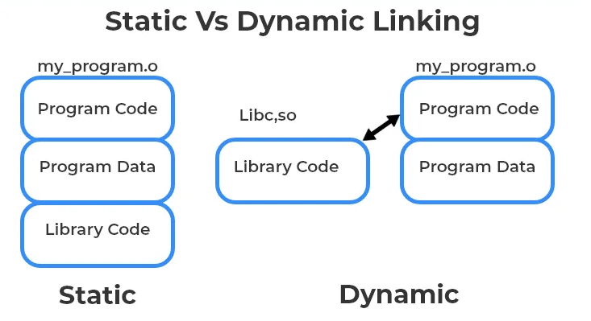
EDRTEST PROGRAM (USING A DLL IN PRACTICE) 🧪
1. What EDRTEST Is
EDRTEST.EXE is a normal Win32 GUI program whose only purpose is to prove DLL usage works.
It does not:
- Implement text-centering logic
- Know how drawing is done
- Care about encoding details
It delegates that responsibility to EDRLIB.DLL.
This is correct architecture.

2. Structure of the Program
EDRTEST follows the standard Win32 skeleton:
- WinMain
- Window class registration
- CreateWindow
- Message loop
- WndProc
Nothing special here — and that’s intentional.
The focus is on integration, not novelty.

3. Including the DLL Interface
The program includes:
This header:
- Exposes exported functions
- Hides implementation details
- Acts as a contract
Important:
EDRTEST never sees the DLL’s source code.
That separation is the entire point.

4. Where the DLL Is Used (WM_PAINT)
The DLL is used only during painting.
Flow inside WM_PAINT:
- Call BeginPaint → get HDC
- Call GetClientRect → get drawable area
- Call EdrCenterText
- Call EndPaint
The DLL:
- Measures text
- Calculates centering
- Draws the output
The EXE:
- Just asks for results
This is clean responsibility separation.

5. Why This Design Matters
Benefits shown clearly:
- Reusability → any program can reuse EDRLIB.DLL
- Replaceability → DLL can change without recompiling EXE
- Testability → EXE tests the DLL in isolation
- Simplicity → EXE code stays small
This is how large Windows apps are structured.

6. Message Loop and Lifetime
The message loop:
- Uses GetMessage
- Dispatches messages
- Ends on WM_QUIT
The DLL:
- Is loaded automatically at startup
- Remains loaded for the process lifetime
- Is unloaded at program exit
The EXE never manually loads or unloads it.

7. Expected Output
When run:
- A window appears
- Title: DLL Demonstration Program
- Text appears centered
- Text rendering is done entirely by the DLL
If the DLL fails:
- Program may fail to start
- Or crash on call
This shows how critical DLL correctness is.

SHARED MEMORY IN DLLs ⚠️
(Breaking Isolation on Purpose)
8. Default Reality: DLLs Are Isolated
Normally:
- Each process has its own data
- Global variables are per process
- DLL code is shared
- DLL memory is not
This is safe by default.

9. When Shared Memory Is Needed
Sometimes you want:
- Multiple programs
- Multiple instances
- Shared state
- Central coordination
Examples:
- Caches
- Logs
- String registries
- License tracking
- IPC helpers
This requires explicit shared memory.

STRLIB.DLL — A SHARED STRING STORE 🧠
10. Purpose of STRLIB
STRLIB:
- Stores up to 256 strings
- Capitalizes them
- Sorts them
- Shares them across processes
This is not normal DLL behavior — it’s deliberate.
STRLIB.H (Header File)
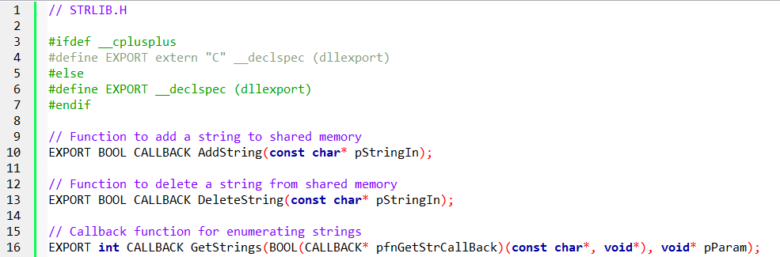
STRLIB.C (Implementation File)
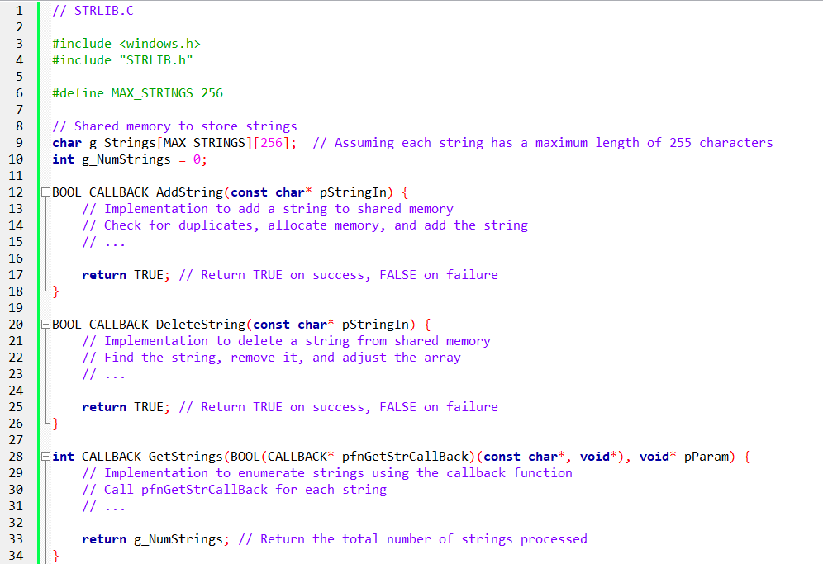
11. Core Functions Provided
AddString
- Adds a string to shared memory
- Capitalizes internally
- Allows duplicates
- Fails if:
  - Empty string
  - Allocation failure
  - 256-string limit reached
Returns:
- TRUE → success
- FALSE → failure

DeleteString
- Removes the first matching string
- Does nothing if not found
- Safe operation
Returns:
- TRUE → deleted
- FALSE → failed or not found

GetStrings (Callback-Based)
This is the important one.
- STRLIB does not return a list
- Instead, it calls back into the EXE
Flow:
- Program passes a callback function
- DLL iterates its shared strings
- DLL calls the callback once per string
- Enumeration stops when callback returns FALSE
Why this design?
- No shared ownership
- No buffer guessing
- No memory ownership confusion
This is professional API design.

12. Unicode Strategy
Internally:
- STRLIB stores everything in Unicode
Externally:
- Provides A and W APIs
- Converts when needed
Result:
- One internal representation
- Multiple consumer types
- Clean separation
This avoids data corruption and encoding bugs.

STRPROG.EXE — USING SHARED MEMORY 🧪
STRPROG.C (Test Program)
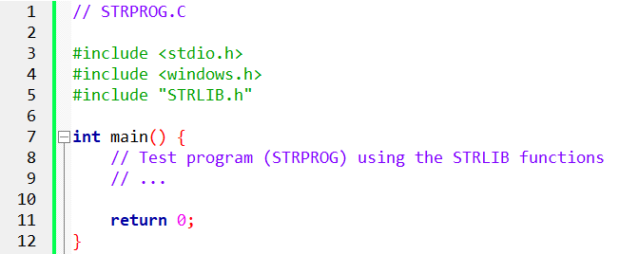

13. What STRPROG Does
STRPROG:
- Has menus (Enter / Delete)
- Shows strings in its client area
- Uses STRLIB for all storage
It owns:
- UI
- Input
- Display
STRLIB owns:
- Data
- Sorting
- Storage
- Sharing
Correct division.

14. Callback in Practice
STRPROG defines:
- A callback function
- Receives strings one-by-one
- Displays them
STRLIB:
- Knows nothing about UI
- Knows nothing about windows
- Only knows how to enumerate
This keeps the DLL generic and reusable.

HOW SHARED MEMORY IS DONE 🔐
15. Memory-Mapped Files
Shared memory in Windows uses:
- File mapping objects
- Named mappings
- Same name → same memory
All processes:
- Map the same memory region
- See the same data
- Must synchronize access
This is powerful — and dangerous.

16. Synchronization Is Mandatory
Shared memory requires:
- Mutexes
- Critical sections
- Careful design
Without synchronization:
- Data corruption
- Random crashes
- Undefined behavior
Rule:
Shared memory without locks is a time bomb.

FINAL MENTAL MODELS 🧠
17. EDRTEST Lesson
- EXE = UI + coordination
- DLL = logic + capability
- WM_PAINT = integration point
- Headers = contracts

18. STRLIB Lesson
- DLLs can share memory — but only intentionally
- Callbacks avoid ownership problems
- Unicode-first design is mandatory
- Synchronization is non-negotiable

19. Big Picture
- DLLs scale software
- Shared memory scales systems
- Bad DLLs crash everything
- Good DLLs disappear into reliability
This is real Windows engineering, not tutorial fluff.
That’s why the former chapters were a necessary foundation.

STRLIB LIBRARY PROGRAM 🧩
1. Purpose and Structure
STRLIB is a DLL that provides string management through shared memory.
Multiple processes can access and modify the same string list.
It consists of:
- STRLIB.H → interface and contracts
- STRLIB.C → implementation and shared memory logic

2. STRLIB.H (Header Design)
- Constants
  - Maximum number of strings
  - Maximum length per string
These define the fixed size of the shared memory.
- Callback Function Type
  - Declares a callback used for string retrieval
  - The calling program (e.g. STRPROG) must implement it
  - STRLIB does not decide what to do with strings — it only delivers them
- Design Intent
  - STRLIB manages data
  - The caller manages presentation and behavior
This separation is deliberate.

3. STRLIB.C (Implementation Core)
- Required Headers
  - windows.h → shared memory, DLL behavior
  - wchar.h → Unicode string handling
- Shared Memory Section
  - Created using #pragma data_seg("shared")
  - This section is shared across all processes loading the DLL
- Shared Variables
a) iTotal
  - Tracks how many strings are stored
  - Updated on add/delete operations
b) szStrings
  - 2D array of strings
  - Capacity: 256 strings
  - Max length: 63 characters
  - Stored internally as Unicode
- Linker Configuration
  - /SECTION:shared,RWS
  - Ensures the section is:
    - Readable
    - Writable
    - Shared across processes
Without this, the memory would not actually be shared.

EXPORTED FUNCTIONS 🛠️
1. AddString (A/W)
- Behavior
  - Accepts an input string
  - Converts it to uppercase
  - Inserts it into the array in alphabetical order
- Duplicate Handling
  - Duplicates are allowed
  - No uniqueness enforcement
- Result
  - Returns success or failure
  - Failure usually means capacity limits

2. DeleteString (A/W)
- Behavior
  - Searches for the first matching string
  - Removes only the first occurrence
- Design Choice
  - Predictable deletion
  - No mass removal side effects
- Result
  - Returns success or failure

3. GetStrings (A/W)
- Core Mechanism
  - Iterates through shared memory
  - Calls a callback for each string
- Control Flow
  - Stops when:
    - All strings are processed, or
    - The callback returns FALSE
- Return Value
  - Number of strings actually processed
STRLIB never paints, prints, or logs. It enumerates only.

SHARED MEMORY MODEL 🧠
1. Why Shared Memory
- Windows isolates process memory by default
- Shared memory allows:
  - Zero-copy data access
  - Immediate visibility across processes
2. How STRLIB Achieves It
- Defines a shared section
- Places data inside it
- Marks it shared at link time
- All processes loading STRLIB map the same memory
No pipes.
No sockets.
No IPC ceremony.

3. Memory Layout
- iTotal → 4 bytes
- szStrings → fixed-size buffer
- Total size ≈ 32 KB
Static, predictable, fast.

4. Alternative Approach
- File Mapping Objects
- Useful when:
  - Size must be dynamic
  - Data lifetime must outlive the DLL
STRLIB uses the simpler, static model intentionally.

UNICODE HANDLING 🔤
Internal Rule - All strings are stored as Unicode.
1. Dual API Design
- A functions → ANSI callers
- W functions → Unicode callers
- UNICODE macro selects automatically
2. Conversion Logic
- ANSI caller
  - Convert ANSI → Unicode
  - Process internally
  - Convert back when returning data
- Unicode caller
  - No conversion required
This guarantees consistency and compatibility.
CALLBACK DESIGN 🔁
1. Purpose
- STRLIB does not own presentation logic.
- The caller decides how strings are used.
2. Callback Flow
- Caller passes:
  - Callback function pointer
  - User-defined parameter
- STRLIB:
  - Calls callback for each string
  - Stops if callback returns FALSE

3. Advantage
- Flexible
- Extensible
- No coupling between DLL and UI

DLL EXPORTS AND LIFECYCLE ⚙️
1. Exporting Functions
- Export macro marks functions as public
- Allows external programs to link and call them
2. DllMain
- Called on load/unload
- STRLIB’s implementation:
  - Does nothing
  - Returns TRUE
This is acceptable because:
- Shared memory is static
- No per-process initialization required

STRPROG PROGRAM
1. Role
STRPROG is a demonstration client for STRLIB.
It shows:
- Shared memory in action
- Multi-instance synchronization
- DLL-based architecture

2. Program Structure
- Registers a window class
- Creates the main window
- Enters a standard message loop
- Delegates logic to WndProc

3. Message Handling
- WM_CREATE
  - Registers a custom message for data changes
- WM_COMMAND
  - Enter string → AddString
  - Delete string → DeleteString
  - Broadcasts update message
- WM_PAINT
  - Calls GetStrings
  - Callback renders strings using TextOut
- WM_DESTROY
  - Posts WM_QUIT

4. Dialog Boxes
- EnterDlg → input new string
- DeleteDlg → input string to remove
- Handled via dialog procedures
- Defined in resource file

MULTI-INSTANCE SYNCHRONIZATION 🔔
1. Shared Data
- All instances read/write the same memory
2. Notification Model
- Custom registered message
- Broadcast to all STRPROG windows
- Forces repaint and refresh
Shared memory gives the data.
Messages give the awareness.

DLL MESSAGE AND RESOURCE RULES 📦
1. Message Queues
- DLLs have no message queues
- They operate through the caller’s queue
2. Resource Loading
- DLL instance handle → DLL resources
- App instance handle → App resources
3. Windows and Classes
- Windows created by DLLs still deliver messages to the caller’s queue
- Best practice: Use caller’s instance handle unless there’s a strong reason not to
4. Modal Dialogs
- Modal dialogs run their own loop
- DLLs can safely create them
- Parent window can be NULL

KEY TAKEAWAYS 🧠
- STRLIB
  - Shared memory DLL
  - Unicode-first design
  - Callback-based enumeration
- STRPROG
  - Thin UI client
  - Demonstrates real inter-process sharing
- Architecture Lessons
  - Shared memory beats IPC for speed
  - DLLs are extensions, not applications
  - Separation of data, logic, and UI is non-negotiable
This is real WinAPI thinking, not academic filler.

DYNAMIC LINKING FLEXIBILITY ⚡
1. Concept
Instead of linking a library at compile-time (static dynamic linking), you can load a library at runtime.
This is essential when:
- Library names are unknown at compile time
- Functionality depends on runtime conditions
- You’re building plugins or modular components

2. Example: Rectangle in GDI32
Static linking:
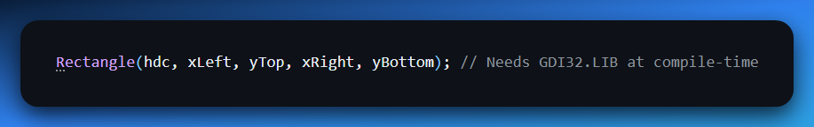
Runtime linking:
a) Typedef the function pointer:
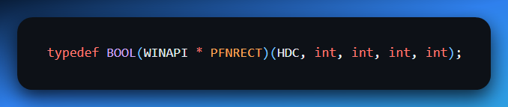
b) Declare library handle and pointer:
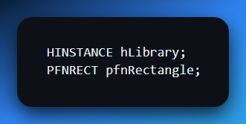
c) Load library and get function address:
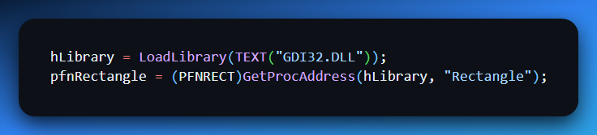

d) Call through pointer:
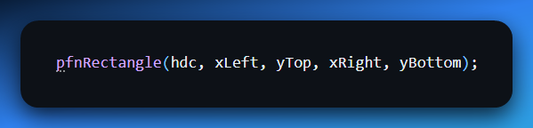
e) Unload when done:
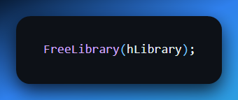
3. Steps in Short
- Define a function pointer type
- Declare library handle + pointer
- Load with LoadLibrary
- Retrieve function with GetProcAddress
- Call the function
- Release library with FreeLibrary

4. Use Cases
- Unknown library names at runtime
- Conditional functionality (user settings, config files)
- Plugin architectures (load/unload modules on demand)

5. Internal Mechanisms
Reference counting:
- LoadLibrary increments count
- FreeLibrary decrements count
- Program exit decrements count automatically
- When count = 0 → memory is freed
Memory management:
- Library memory stays until reference count hits 0
- Ensures active users are unaffected

6. Benefits
- Flexibility → Decide which libraries to use at runtime
- Reduced dependencies → Only load what you need
- Modular design → Swap or update components dynamically

Resource-Only Libraries (ROLs)
1. Purpose
- Contain only resources (bitmaps, icons, dialogs, strings, menus)
- No exported functions
- Reusable across multiple programs

2. Common Uses
- Bitmaps → Multiple resolutions
- Icons, menus, dialogs, strings → Shared UI elements
- Language packs → Centralized localization

3. Creation
- Resource script (.RC)
- Compile with RC.EXE → .RES file
- Link .RES into DLL → ROL
Example: BITLIB.DLL
- Nine bitmaps: BITMAP1.BMP → BITMAP9.BMP
- Defined in BITLIB.RC
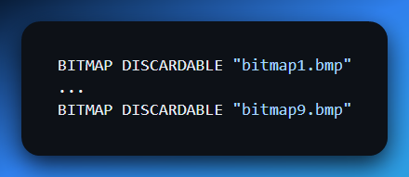
DllMain is minimal:
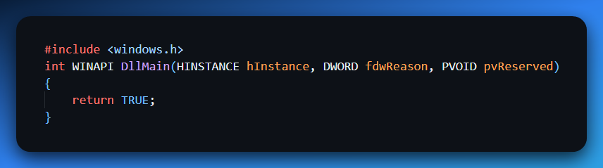
Build independently, no .LIB file needed

4. Using ROLs in Programs
- Example: SHOWBIT
  - Loads BITLIB.DLL at runtime
  - Reads bitmaps with LoadBitmap(hLibrary, MAKEINTRESOURCE(id))
  - Draws them in window
  - Allows cycling with keyboard
Key points:
- InvalidateRect triggers repaint
- Bitmaps drawn via DrawBitmap:
  - Create compatible DC
  - Select bitmap
  - BitBlt to window DC
  - Cleanup memory DC
- Free library on WM_DESTROY

5. Benefits
- Modular resource management
- Customizable resources (display resolutions, language)
- Simplified distribution → Update resources without touching code
- Shared usage → Multiple instances of the program use the same DLL

SHOWBIT PROGRAM Overview 🖥️
Purpose: Load & display bitmaps from BITLIB.DLL
Flow:
- Register window, create main window
- Enter message loop
- Handle messages:
  - WM_CREATE → Load BITLIB.DLL
  - WM_CHAR → Cycle bitmaps
  - WM_PAINT → Draw current bitmap
  - WM_DESTROY → FreeLibrary + exit
DrawBitmap helper:
  - Memory DC + BitBlt
  - Copies bitmap to window
  - Cleans up DC
Notes on ROL loading:
- If DLL not found → Windows searches PATH
- Resources are shared among multiple instances
- Last instance exit → BITLIB memory freed

Takeaways
- Dynamic linking at runtime
  - Loads DLLs as needed
  - Supports plugin/modular architectures
- Resource-only libraries
  - Separate resource management
  - Share resources efficiently
- Reference counting & memory
  - Safe shared usage
  - Frees memory when no users remain
- SHOWBIT demo
  - Practical example of dynamic and resource-only DLL usage

Next up is chapter 22 – sounds, so you can literally step into multimedia, audio handling, and WinAPI sound messages. 🎵
